Navigating Market Sentiment: A Multi-Asset Performance Study Based on the VIX Index
In the volatile landscape of capital markets, the VIX (Volatility Index), often referred to as the "fear index," serves as a barometer of investor sentiment. This study centers around the VIX to address a fundamental question: how do asset performances differ across various stages of market sentiment? More importantly, can we design superior investment strategies based on these emotional shifts?
To answer this, we first retrieved historical data (2008-2024) from Yahoo Finance covering major assets: SP500, Gold, Long-Term Treasuries (TLT), Oil, and Bitcoin. The VIX was introduced as the central sentiment indicator. After cleaning and aligning the time series, we created a consolidated dataset named "multi_asset_market_data_cleaned.csv," which served as the foundation for all subsequent analysis and strategy development.

Sentiment Classification: Establishing an Analytical Framework
To bridge asset performance with investor sentiment, we categorized the VIX into three stages:
- Low (VIX < 20): Optimistic markets with stable sentiment;
- Medium (20 ≤ VIX ≤ 30): Rising concerns and increased volatility;
- High (VIX > 30): Panic dominates, and flight-to-safety behavior prevails.
These labels enabled sentiment-driven grouping of observations, serving as the basis for deeper asset behavior insights.

Asset Portraits: Return and Risk Across Sentiment Phases
We analyzed five representative assets (SP500, Gold, TLT, Oil, and Bitcoin) and computed their annualized return, volatility, and Sharpe ratio under each sentiment condition.
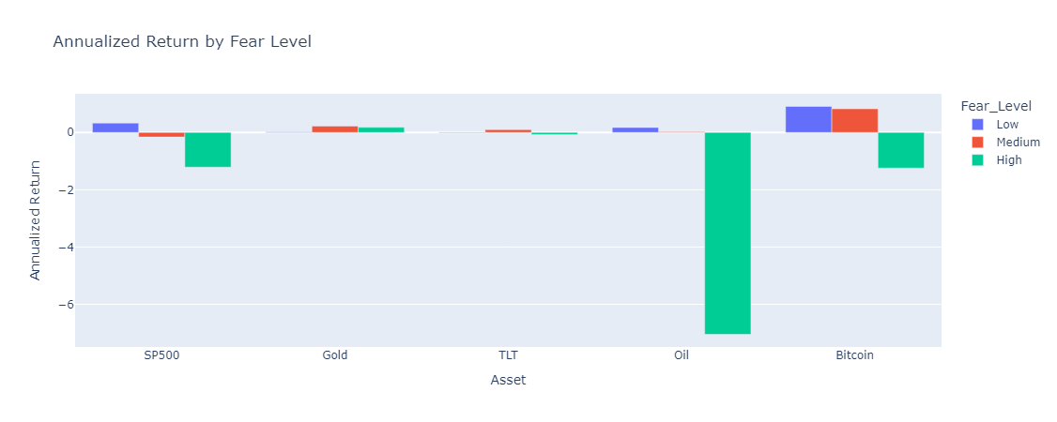
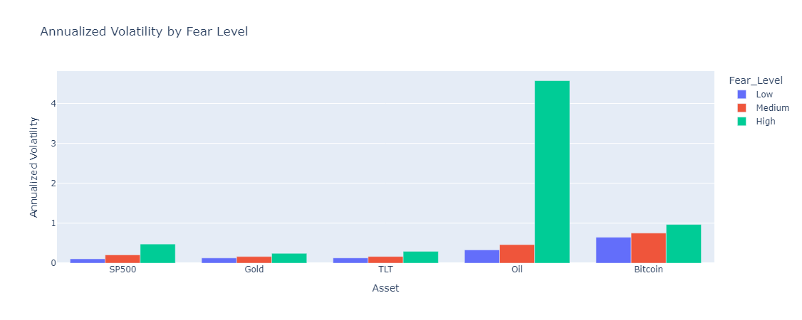
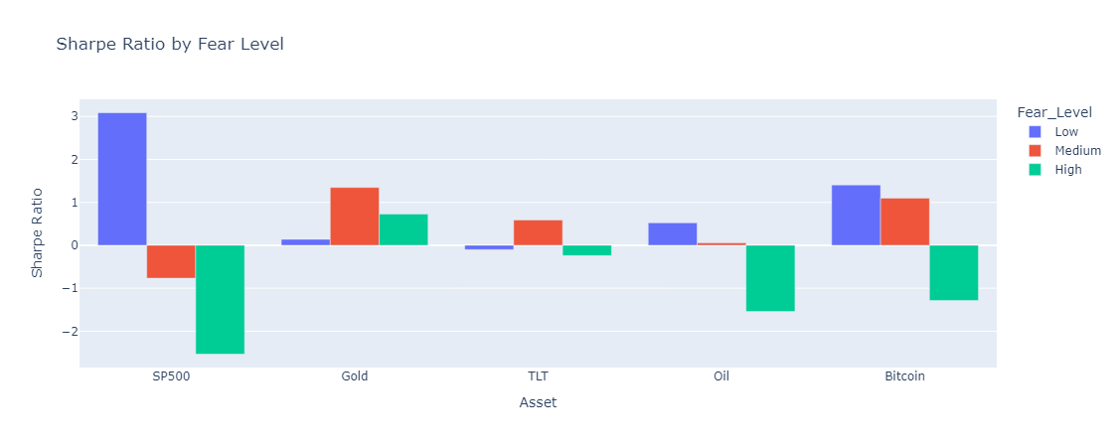

Figure 1 reveals that under low-VIX environments, SP500 and Bitcoin exhibit strong risk-on characteristics. However, their annualized returns deteriorate significantly as fear levels rise.
Figure 2 presents the annualized volatility. Oil and Bitcoin show a sharp spike in volatility under high-VIX regimes, indicating heightened risk exposure. In contrast, Gold and TLT remain comparatively stable, highlighting their defensive characteristics.
Figure 3 highlights Sharpe ratios, a risk-adjusted performance metric. Most assets deliver a positive Sharpe ratio only during Low-VIX conditions. Under High-VIX regimes, nearly all Sharpe ratios plummet, demonstrating the diminishing appeal of risk assets when fear surges.
This cluster of charts offers a static snapshot of how sentiment reshapes return-risk profiles. Importantly, they provide essential clues for our upcoming strategy design. These results reveal that asset "personalities" adapt to their environment—some shine during confidence, others preserve value during panic.
To gain a more dynamic perspective, we added drawdown analysis to observe downside risk.
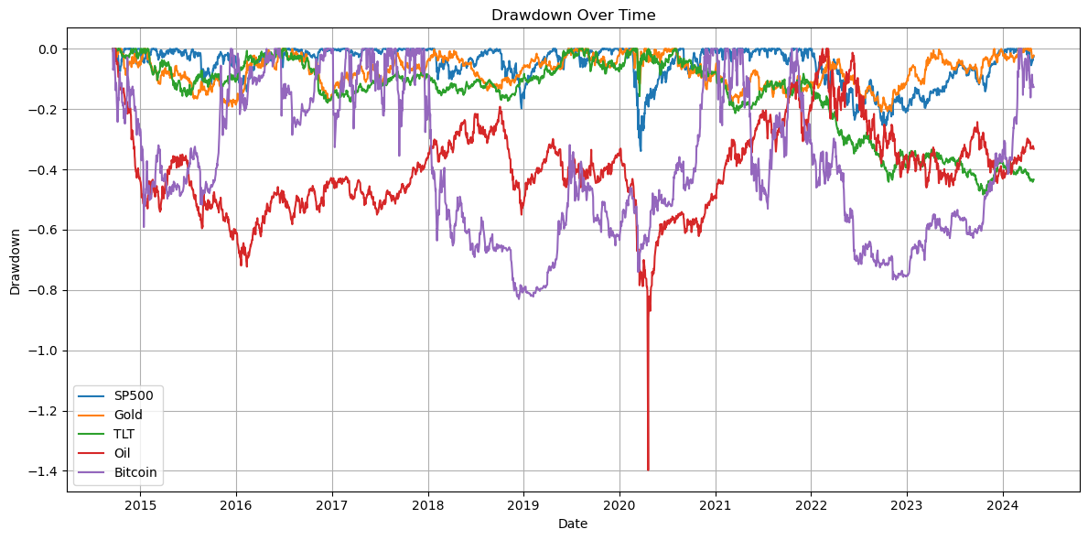
Figure 4: Maximum Drawdowns Across Assets
Oil and Bitcoin experience the most severe drawdowns, particularly during the COVID-19 onset and energy price crashes. In contrast, Gold and Treasuries showcase smaller drawdowns, reinforcing their role as safe havens. This view adds another dimension to risk assessment, especially in high-volatility environments.
This shift in analytical direction raised a critical question: could we anticipate emotional surges and asset fragility by tracking the VIX over time?
The Evolution of Volatility: Mapping Emotional Turbulence
To visualize sentiment transitions, we charted the VIX's historical path and marked periods using our three sentiment stages.
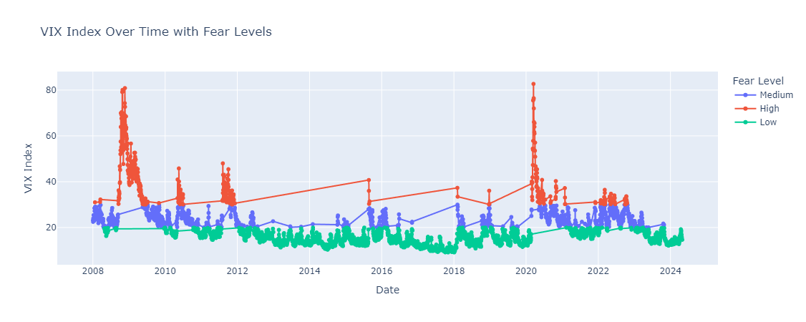
Figure 5: Historical VIX Timeline with Sentiment Phases
From the 2008 financial crisis, the 2011 Euro debt crisis, to the 2020 COVID-19 shock, each VIX peak corresponds to a real-world market shock. Color-coded phases show how sentiment states evolve and cluster in time.
Interestingly, sentiment spikes often emerge abruptly and subside slowly, suggesting asymmetric dynamics. This insight is crucial for modeling strategies and affirms the VIX's representativeness as a sentiment proxy.

Correlation Shifts: Inter-Asset Relationships under Emotional Stress
Next, we explored whether inter-asset relationships shift across sentiment regimes using heatmaps. 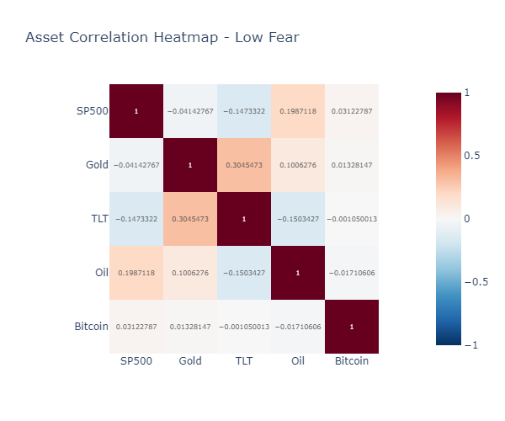
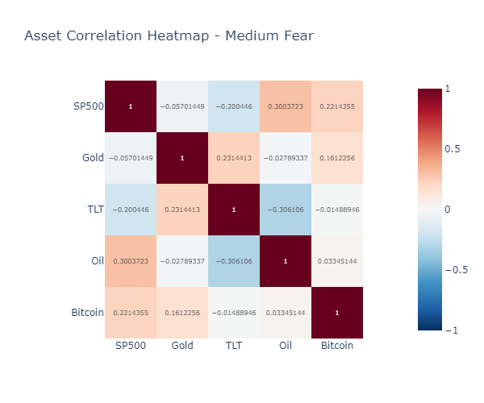
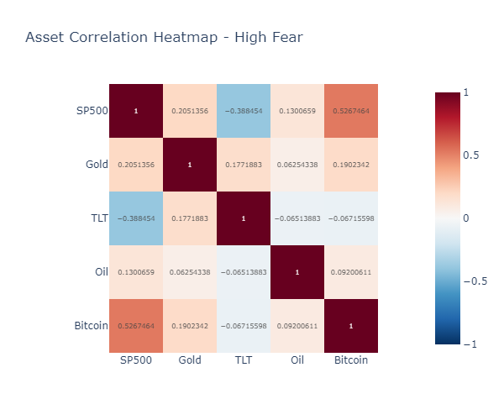
Figures 6-8: Correlation Heatmaps under Low, Medium, and High Sentiment
- In the Low phase, asset correlations remain weak, supporting diversification.
- In the Medium phase, correlations begin to rise, especially among Oil, SP500, and Bitcoin, signaling early-stage systemic risk.
- In the High phase, Bitcoin's correlation with SP500 spikes, undermining its narrative as a non-correlated asset. Meanwhile, Treasuries exhibit negative correlation with equities, reinforcing their hedge role.
These observations imply that correlation structures themselves evolve under stress, challenging static diversification assumptions. Portfolio construction must therefore be sentiment-aware.

Visualizing Distribution: VIX's Shape in Different Regimes
To understand the statistical distribution of VIX under each sentiment phase, we used violin plots.
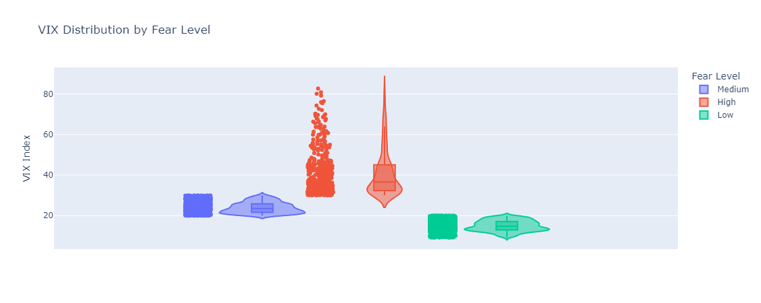
Figure 9: Violin Plot of VIX Distributions
This hybrid chart illustrates both the range and probability density. Under Low conditions, VIX values are tightly clustered. Medium regimes exhibit moderate spread, hinting at instability. High regimes feature long right tails, highlighting frequent extreme spikes.
Such tail-risk awareness is critical: traditional models underestimate this behavior, while sentiment tagging helps quantify it.

Strategy Development: Can Emotions Guide Better Portfolios?
Our final section applies these insights to strategy building. We began with a VIX-driven rotational strategy:
- Fear-Level Switching Strategy: SP500 during Low, Gold in Medium, TLT in High.
Compared against a static SP500 benchmark, this adaptive strategy yielded improved Sharpe ratios and smaller drawdowns. Encouraged by this result, we tested additional strategies:
- Equal-Weight Strategy: Equal allocation to five assets, representing a conventional diversified portfolio.
- Risk-On/Off Strategy: SP500 + Bitcoin during Low; Gold + TLT during High; no position during Medium.
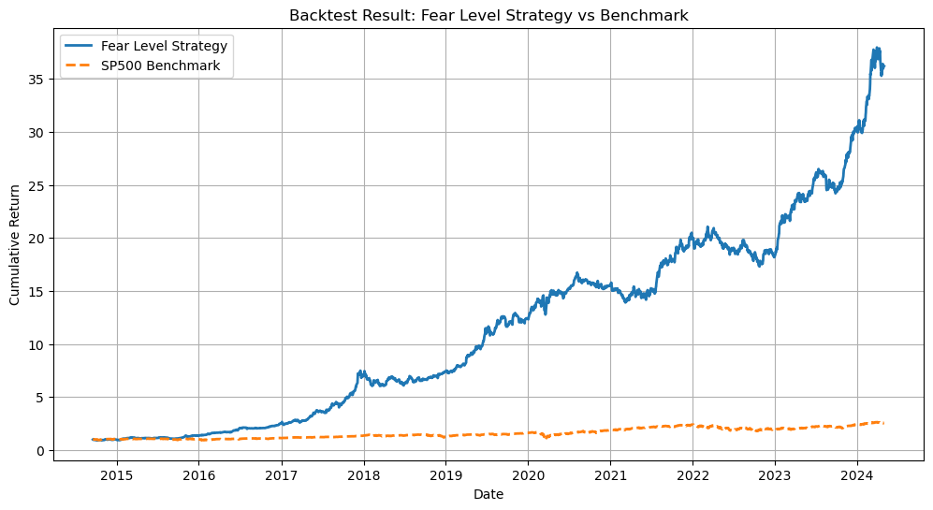
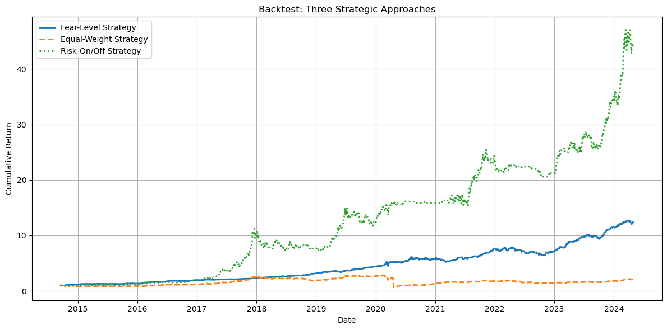
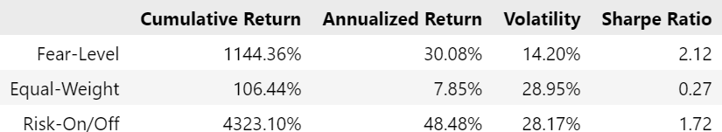Figures 10-12: Backtest Results + Performance Metrics Table
Key Takeaways:
- The Fear-Level Strategy delivered balanced performance across metrics, with a Sharpe ratio of 2.12 and annualized return of 30.08%.
- The Equal-Weight Strategy offered lower volatility but a modest Sharpe ratio of 0.27.
- The Risk-On/Off Strategy achieved high returns (48.48%) but suffered from elevated volatility (28.8%), indicating instability.
This validates our hypothesis: sentiment tags not only explain market dynamics but can also serve as robust signals for tactical asset allocation.

Visualization Architecture and Theory: From Insight to Interaction
We leveraged Dash and Plotly to build a full-featured interactive dashboard:
- Used dcc.Tabs and modular layouts to segment analysis by theme;
- Applied dropdowns and checklists to enable sentiment-asset-date filtering;
- Created multiple chart types (bar charts, violin plots, heatmaps, cumulative return lines, drawdowns);
- Employed consistent color encodings, axis limits, and legends to maintain structural clarity;
- Enabled user interaction with tooltips, legends, and sliders for exploratory flexibility.
The design draws from Edward Tufte's visualization principles:
- Data Density: Maximizing information per chart using layers, overlays, and compact small multiples;
- Data-Ink Ratio: Reducing visual clutter to focus on key data elements;
- Small Multiples: Allowing side-by-side comparisons across sentiment phases;
- Hierarchical Consistency: Ensuring layout and labels follow predictable patterns;
- User Control: Letting readers filter and navigate instead of passively viewing.
This theory-backed, user-driven interface enhances both analytical rigor and accessibility.
Conclusion: Interpreting Emotion, Navigating Risk
By quantifying investor sentiment through the VIX and mapping it to asset behaviors, this study illuminates how emotions shape both return profiles and asset correlations. Our sentiment-aware strategies prove that emotional indicators can be translated into actionable rules.
Future research may integrate more granular emotion scores or machine learning for sentiment prediction. As markets evolve, understanding sentiment may not just enhance portfolios—it may be the key to enduring volatility with insight and confidence.

